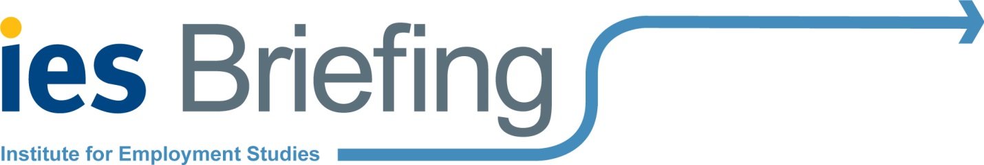
Technical Education Work Placements Pilots Evaluation
Your local college has advised us that you are hosting (or considering hosting) one of their learners on a work placement, as part of the Work Placements Pilots. The Department for Education has commissioned the Institute for Employment Studies to evaluate the pilots and we are interested in speaking to employers about their experience of the Work Placements Pilot so far. We would be very grateful if you could spare the time for a phone interview of about 45 minutes (or less, if the work placement is at an early stage). Please could you email us back to let us know your availability and the best number to reach you on?

What is the evaluation and why is it taking place?
As you may know, new technical qualifications (‘T levels’) will be introduced in 2020 and will entitle every 16 to 19-year-old learner undertaking a college-based technical education route to a high quality work placement of approximately 45-60 working days that develops their technical skills. To prepare for the T levels, the Department for Education (DfE) is piloting these substantial work placements with selected colleges across England.
The Department has asked IES to evaluate the pilots to identify which work placement models (e.g. day release or block placements) are effective and why, and to assess the successes and challenges for everyone involved: employers, colleges and learners. We have already interviewed staff at the local college, and in the spring we will be interviewing learners. We would be delighted to hear your views, as a local employer. We appreciate that you are busy and we would be very grateful for your support with this research. Your contributions are immensely valuable in the design of the new work placements policy, which aims to provide high quality, work ready young people.

Frequently asked questions:
What help are we requesting from employers? Frank and honest discussions with you about, for example: how you came to be involved with the pilot, your relationship with the local college/another organisation running the pilot, why you decided to take on a learner(s) or are considering doing so, how you selected the learner(s), how you helped them to prepare for their placement, what tasks the learner is undertaking, how the learner is supported during the placement, how they are assessed, the impact of the work placements pilot, how you would do things differently next time.

How much time will the interview take?
The telephone interview will take about 45 minutes (or less if the work placement is at an early stage).

How did you get my contact information?
Your local college provided us with your contact details.
How will you protect my personal data?
Neither your local college nor the Department for Education will be told which employers have taken part in the research. We will report all findings without identifying organisations or individuals. Your answers will be completely confidential and the findings will be reported anonymously.
We operate in-line with data protection legislation: we will store your personal data securely, we will not use your personal data for anything other than this research and your personal data will be deleted from our records at the end of the project. Should you decide you would prefer not to be re-contacted for this project, please let us know and we will remove your personal data from our records.
Who can I talk to about the evaluation?
If you have any questions about the evaluation, you can contact:
Department for Education | Institute for Employment Studies
Richard Moore, Senior Social Researcher  E: richard.moore@education.gov.uk  T: 07384 237 375 | Becci Newton, Principal Research Fellow  E: becci.newton@employment-studies.co.uk  T: 01273 763 441

